## Merchant Name: BenefitFlow Implementation POC: Royce *(IM to fill)* CX POC: *[IMP to Add]*

### 

### 

| Notes Sections   *(AE to fill if they have, Implementation to be completion DRI on handoff)*   * Info on how merchant bills   + Flat fees but within the flat fee a certain amount of credits are included. Do not charge for overages today   + Majority of customers are annually billed but some are monthly or quarterly   + Everything today is manual   1) What is the merchant temperament?   * Pedro is the first finance hire and pretty easy going. Him and I are on a texting basis * I have not met their outsourced accounting firm who will potentially also use Tabs   3) What are the Tabs features that the key POC cares about?   * Contract ingestion * Auto invoice, billing schedule, and revenue schedule creation * Renewal tracking + auto invoicing for auto renewals * Integrations with HubSpot, QB, and Stripe |
| --- |

### Billing model *(Entire Section: Implementation to fill section)*

* Are there unique things about the customer creation process for this merchant?
* Information on how merchant bills
* How contract is broken up
* One off things to know about the merchant

### Contract Processing Steps *(Entire Section: Implementation/Success to fill Post-Go Live)*

1. Steps to process  
   **Contract Processing Steps**

Generalized instructions for processing BTs from any BenefitFlow customer contract

### **Locate Billing Terms**

* Each billing item line in the product/service table should be its own BT
* Discounted or $0 lines should still be processed as BTs
* Do not make a BT for sales tax

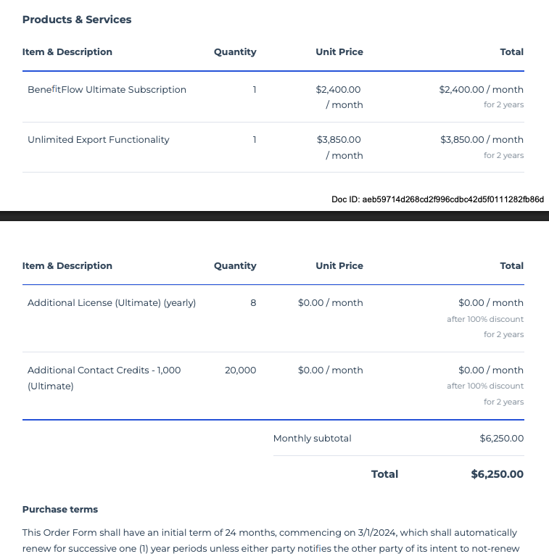

### **Item Name**

* Use the product name listed in the left-hand column of the product/service table  
  Example: "BenefitFlow Enterprise Subscription"

### **Quantity**

* Use the quantity listed for the BT (usually 1)
* If not listed, default to 1

### **Total Price**

* Use the full price listed for the product
* If monthly pricing is shown and subtotal is annualized, calculate based on frequency and unit price
* Process $0 items when clearly marked as included or waived

### **Service Start Date**

* Use the date the contract says the term begins:  
  + If stated: use the "Subscription Start Date", “Signature Date” or similar phrasing
  + If not stated: default to the signature date as listed in the contract body or audit trail
  + If there is no signature date, default to the quote expiration date on the first page, top right hand corner

### **Months of Service**

* Use full contract term as stated
  + Most contracts are 12 months; use 12 unless otherwise noted (e.g., 24-month term in ParetoHealth renewal)

### **Billing Start Date**

* Match Service Start Date unless otherwise stated

### **Frequency**

* Identify frequency based on unit price and payment terms
  + Example: If unit price says "$2,400/month" → Frequency = Monthly
  + If contract shows annual flat rate → Frequency = Annual

### **Net Terms & Billing Timing**

* Use terms listed under "Purchase Terms" or similar
  + If not listed, default to 30 days
* Bill first of period

### **Integration Item**

* All items should be mapped to Sales MRR

### **Example Contracts**

* 31123e53-a4a7-4233-8ac2-074cc361310a  
  7f2dbd74-d931-44ba-a8a8-c0bd403a3913  
  2c7c25d6-e61b-4532-aa68-2ac65c12716f  
  6cdc906a-e1c8-443d-ae8a-5b1a69895d7b  
  76b42735-6d4b-4084-9f1c-86f13af5db4c

1. Anything to ignore in contracts?
2. Specifics processing things the merchant has requested that may differ by contract (e.g. always back-date invoice date to final day of the month)
3. Default Service Term
   1. If None Listed, Ops Default is 1 Year
4. Default Net Payment Terms
   1. If None, Ops Default is 0
5. Default Billing Frequency
   1. If None Listed, Ops Default is Monthly
6. How do we handle taxes as a line item?
   1. If None Listed, Ops Default is every tax line item becomes a BT

### Events Processing (if necessary) *(Entire Section: Implementation/Success to fill Post-Go Live)*

* Any important information on events billing

Integration Items Processing (if necessary)  
*(Entire Section: Implementation/Success to fill Post-Go Live)*

* What are the instructions for assigning integration items?
* Example: All Statsig integrations items should be labeled as “Sales”
* Example: All “Pinata” integration items should be labeled as “Software Subscription Bundle” unless otherwise noted by Merchant

Post Processing Communications (if necessary)  
*(Entire Section: Implementation/Success to fill Post-Go Live)*

* Does the Ops Team need to notify anyone on the team re: completion of processing batches in Implementation or Active phase?
* Who needs to be notified and when?
  + Example:
    - Who: Customer Success [Azmat Aziz] needs to be notified
    - Where: Messari internal merchant channel
    - When: contracts are processed [Merchant Phase: Active]

### Customer Information *(Entire Section: Implementation/Success to fill Post-Go Live)*

* Any important information on specifics customers of this merchant
  + Special memo’s certain invoices require
  + Invoice changes due to merchant/customer relationship

### Feature Requests *(AE to fill for all requests prior to Imp handoff, Imp to fill prior to go-live/Success to fill to fill Post-Go Live)*

* FR 1
  + What is it
  + Why it's important
  + Urgency

### Merchant Calls *(AE to fill for all videos prior to Imp involvement, Imp to fill prior to go-live/Success to fill to fill Post-Go Live)*

* [June 9th](https://us-56595.app.gong.io/call?id=1970539070944359571)
* [June 10th](https://us-56595.app.gong.io/call?id=7192728266969742628)
* [June 11th](https://us-56595.app.gong.io/call?id=7652561761596575128)
* [June 15th](https://us-56595.app.gong.io/call?id=353551436857842506&account-id=8473725332370805907)